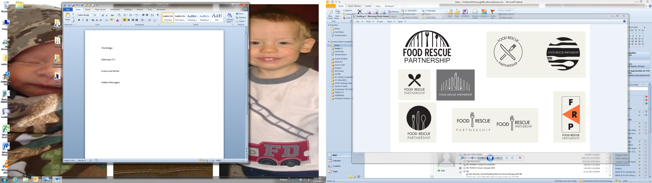

*Feeding People, Not Landfills*

9/10/2024

FOR IMMEDIATE RELEASE

**Contact:** Christina McDonough, Food Rescue Partnership Board Chair, phone: 563-326-8618 ext. 8897, email: [christina.mcdonough@scottcountyiowa.gov](mailto:christina.mcdonough@scottcountyiowa.gov)

**Food Rescue Workshop Releases Full Agenda**

Davenport, IA – The Quad Cities’ Food Rescue Partnership is excited to announce the full agenda for the free Food Rescue Workshop on September 26, 2024, at St. Ambrose University in Davenport, IA during their Sustainability Week.

The workshop agenda features speakers that will follow the U.S. Environmental Protection Agency Wasted Food Scale to showcase the important role everyone can play in reducing food waste. One of the keynote speakers, Yolanda Jefferson, from ChefyBear on Wheels has an extraordinary passion to reduce food waste. She will share tips from her 35+ year culinary career to explain how to prepare and save food by using leftovers and preservation. Yolanda will also share tips to cook on a budget using food pantry ingredients.

“The Food Rescue Workshop will cover every aspect of the food system from spotlighting the Floreciente Community Garden to providing information for the perfect at-home compost recipe,” explains Christina McDonough, Board Chair. Attendees will also learn about volunteer opportunities with Food Rescue US.

For the third time, the Food Rescue Partnership event will announce the Quad Cities Food Rescue Warrior and Member of the Year. Three people from around the Quad Cities were nominated to be recognized for going above and beyond to ensure food is not wasted. The winner of the 2024 Food Rescue Warrior title will be announced at the workshop.

The workshop will take place at St. Ambrose University in Davenport on September 26, 2024, from 7:00-9:00 p.m. There is no cost to attend, and the workshop hopes to draw community members and professional food establishments. Registration and more information is available at [foodrescueqc.org](http://www.foodrescueqc.org).

###

**About the Food Rescue Partnership**

Established in 2013, Food Rescue Partnership is a community-led coalition with a vision to make the Quad Cities a community dedicated to eliminating food waste, by promoting to rescue food for its best possible use. Through collaborative efforts, Food Rescue Partnership has diverted over 58,330 pounds of food from the landfill by connecting professional food establishments and one-time event coordinators to donate access edible food to local non-profit hunger-relief agencies or compost operations. For additional information, please visit [foodrescueqc.org](http://www.foodrescueqc.org).